Sr. no | Aim | Date | Page  No | Sign
1 | Implementing advanced deep learning algorithms such as convolutional neural networks (CNNs) or recurrent neural networks (RNNs) using Python libraries like TensorFlow or PyTorch.
2 | Building a natural language processing (NLP) model for sentiment analysis or text classification.
3 | Creating a chatbot using advanced techniques like transformer models
4 | Developing a recommendation system using collaborative filtering or deep learning approaches.
5 | Implementing a computer vision project, such as object detection or image segmentation.
6 | Applying reinforcement learning algorithms to solve complex decision-making problems.
7 | Utilizing transfer learning to improve model performance on limited datasets
8 | Building a deep learning model for time series forecasting or anomaly detection.
9 | Implementing a machine learning pipeline for automated feature engineering and model selection.
10 | Using advanced optimization techniques like evolutionary algorithms or Bayesian optimization for hyperparameter tuning.
11 | Use Python libraries such as GPT-2 or textgenrnn to train generative models on a corpus of text data and generate new text based on the patterns it has learned.
12 | Experiment with neural networks like GANs (Generative Adversarial Networks) using Python libraries like TensorFlow or PyTorch to generate new images based on a dataset of images.
INDEX
Practical 1
Aim-Implementing advanced deep learning algorithms such as convolutional neural networks (CNNs) or recurrent neural networks (RNNs) using Python libraries like TensorFlow or PyTorch.
Code
import tensorflow as tf
from tensorflow.keras import Sequential
from tensorflow.keras.layers import Embedding ,SimpleRNN,Dense
from tensorflow.keras.datasets import imdb
from tensorflow.keras.preprocessing.sequence import pad_sequences
max_features = 10000
maxlen = 100
(x_train, y_train), (x_test, y_test) = imdb.load_data(num_words=max_features)
x_train= pad_sequences(x_train, maxlen=maxlen)
x_test= pad_sequences(x_test, maxlen=maxlen)
model = Sequential([
Embedding(max_features, 32, input_length=maxlen),
SimpleRNN(32,activation="relu"),
Dense(1,activation="sigmoid")
])
model.compile(loss="binary_crossentropy",optimizer="adam",metrics=["accuracy"])
model.fit(x_train,y_train,epochs=5,batch_size=64,validation_split=0.2)
test_loss, test_acc = model.evaluate(x_test, y_test)
print(f"\nTest accuracy:, {test_acc:2f}")
Output
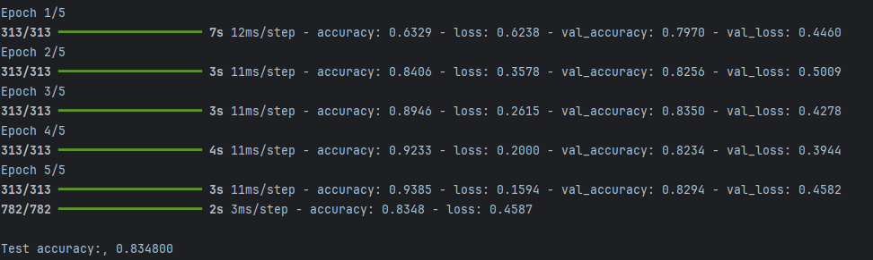
Practical 2
Aim: Building a natural language processing (NLP) model for sentiment analysis or text classification.
Code
from transformers import pipeline
# Load sentiment analysis model
sentiment_analyzer = pipeline(
"sentiment-analysis",
model="distilbert/distilbert-base-uncased-finetuned-sst-2-english"
)

texts = [
"I love this product, it's beautiful",
"The worst service I have ever had in my life",
"I'm not satisfied at all with this experience",
"I'm not happy with the product but still I am satisfied"
]

def analyze_sentiment(texts):
for text in texts:
result = sentiment_analyzer(text)
label = result[0]["label"]
score = result[0]["score"]
print(f"Text: {text}\nSentiment: {label} (Confidence: {score:.2f})\n")

# Call the function
analyze_sentiment(texts)
Output
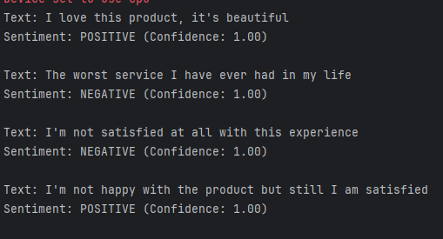

Practical 3
Aim: Creating a chatbot using advanced techniques like transformer models
Code
from transformers import AutoModelForCausalLM, AutoTokenizer
import torch
import warnings
# Optional: suppress warnings for cleaner output
warnings.filterwarnings("ignore")
torch.set_grad_enabled(False)
# Load pretrained model and tokenizer
model_name = "microsoft/DialoGPT-medium"
print(f"Loading model: {model_name} ...")
tokenizer = AutoTokenizer.from_pretrained(model_name)
model = AutoModelForCausalLM.from_pretrained(model_name)
print("\nChatbot: Hello! I'm here to chat with you. Type 'exit' to end this conversation.\n")
# Track conversation history
chat_history_ids = None
while True:
user_input = input("You: ")
if user_input.lower() == "exit":
print("Chatbot: Goodbye!")
break
# Encode user input and append to chat history
new_input_ids = tokenizer.encode(user_input + tokenizer.eos_token, return_tensors="pt")
# Append new input to chat history
bot_input_ids = torch.cat([chat_history_ids, new_input_ids], dim=-1) if chat_history_ids is not None else new_input_ids
# Generate a response
chat_history_ids = model.generate(
bot_input_ids,
max_length=1000,
pad_token_id=tokenizer.eos_token_id,
do_sample=True,
top_k=50,
top_p=0.95
)
# Decode and print the latest output
response = tokenizer.decode(chat_history_ids[:, bot_input_ids.shape[-1]:][0], skip_special_tokens=True)
print(f"Chatbot: {response}")
Output
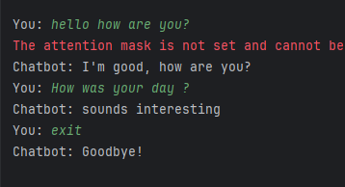

Practical 4
Aim: Developing a recommendation system using collaborative filtering or deep learning approaches.
Code
import pandas as pd
import numpy as np
from sklearn.metrics.pairwise import cosine_similarity
from sklearn.preprocessing import StandardScaler
# Read your dataset
df = pd.read_csv("E:\\Advanced AI\\rating2.csv")
# Adjust these column names to match your CSV exactly
df.columns = df.columns.str.strip().str.lower()
# Now pivot the table
interaction_matrix = df.pivot(index="userid", columns="movieid", values="rating").fillna(0)
# Scale the data
scaler = StandardScaler(with_mean=False)
interaction_matrix_scaled = scaler.fit_transform(interaction_matrix)
# Compute cosine similarity
user_similarity = cosine_similarity(interaction_matrix_scaled)
user_similarity_df = pd.DataFrame(
user_similarity,
index=interaction_matrix.index,
columns=interaction_matrix.index
)
# Recommendation function
def recommend(user_id, k=5):
if user_id not in interaction_matrix.index:
print(f"User ID {user_id} not found.")
return []
# Find similar users (excluding the user themselves)
similar_users = user_similarity_df[user_id].sort_values(ascending=False)[1:k+1]
# Weighted average of ratings from similar users
similar_users_ratings = interaction_matrix.loc[similar_users.index]
weighted_sum = similar_users_ratings.T.dot(similar_users)
sum_of_weights = similar_users.sum()
# Normalize
weighted_rating = weighted_sum / sum_of_weights
# Filter out movies the user has already rated
user_rated = interaction_matrix.loc[user_id]
recommendations = weighted_rating[user_rated == 0].sort_values(ascending=False).head(k)
return recommendations.index.tolist()
# Run the recommender
userID = int(input("Enter User ID: "))
recommendations = recommend(userID)
print(f"\n Recommendations for User {userID}: {recommendations}")
output
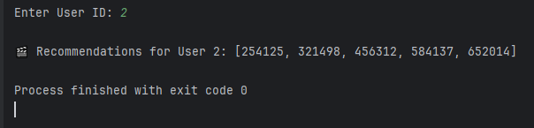

Practical 5
Aim: Implementing a computer vision project, such as object detection or image segmentation.
Code
# === YOLOv8 Object Detection using OpenCV ===
from ultralytics import YOLO
import cv2
import os
# --------------------------------------------------
# 1. Load YOLOv8 Model
# --------------------------------------------------
# Make sure your path and file name are correct (note: 'yolov8n.pt', not 'yolo8n.pt')
model_path = r"E:/yolov8n.pt"
# Check if model file exists
if not os.path.exists(model_path):
raise FileNotFoundError(f"Model file not found at: {model_path}\n"
f"Download it from https://github.com/ultralytics/assets/releases")
# Load the model
print("Loading YOLOv8 model...")
model = YOLO(model_path)
print("Model loaded successfully!")
# --------------------------------------------------
# 2. Run Detection on an Image
# --------------------------------------------------
image_path = r"E:\Advanced AI\panda.jpg"
# Check if image file exists
if not os.path.exists(image_path):
raise FileNotFoundError(f"Image file not found at: {image_path}")
print("Running object detection...")
results = model(image_path) # Perform inference
# --------------------------------------------------
# 3. Visualize the Results
# --------------------------------------------------
# Get the annotated image with bounding boxes
image = results[0].plot()
# Resize for better viewing
resized_image = cv2.resize(image, (800, 800))
# Display with OpenCV
cv2.namedWindow("Processed Image", cv2.WINDOW_NORMAL)
cv2.imshow("Processed Image", resized_image)
print(" Detection complete! Close the image window to exit.")
cv2.waitKey(0)
cv2.destroyAllWindows()
# --------------------------------------------------
# 4. Optional: Save Output
# --------------------------------------------------
output_path = r"E:\Advanced AI\output_result.jpg"
cv2.imwrite(output_path, resized_image)
print(f" Result saved at: {output_path}")
Output
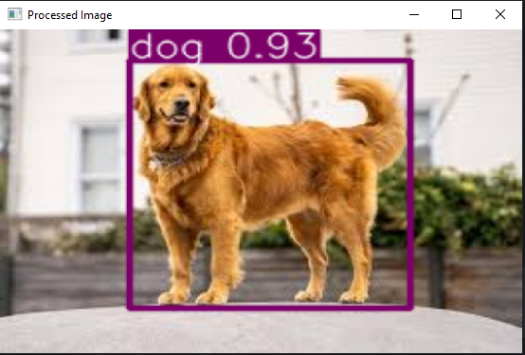
Practical 6
Aim: Applying reinforcement learning algorithms to solve complex decision-making problems.
Code
import numpy as np
import random
# Define the environment
grid_size = 3 # Smaller grid
goal_state = (2, 2)
obstacle_state = (1, 1) # Single obstacle
actions = ['up', 'down', 'left', 'right']
action_to_delta = {
'up': (-1, 0),
'down': (1, 0),
'left': (0, -1),SS
'right': (0, 1)
}
# Initialize Q-table (simple 3D array for states and actions)
q_table = np.zeros((grid_size, grid_size, len(actions)))
# Parameters
alpha = 0.1 # Learning rate
gamma = 0.9 # Discount factor
epsilon = 1.0 # Exploration rate
epsilon_decay = 0.99
min_epsilon = 0.1
episodes = 200 # Fewer episodes
# Reward function
def get_reward(state):
if state == goal_state:
return 10 # Reward for reaching the goal
elif state == obstacle_state:
return -10 # Penalty for hitting the obstacle
return -1 # Step penalty
# Check if the new state is valid
def is_valid_state(state):
return 0 <= state[0] < grid_size and 0 <= state[1] < grid_size and state != obstacle_state
# Main Q-learning loop
for episode in range(episodes):
state = (0, 0) # Start at the top-left corner
total_reward = 0
while state != goal_state:
# Choose an action (epsilon-greedy strategy)
if random.uniform(0, 1) < epsilon:
action = random.choice(actions) # Explore
else:
action = actions[np.argmax(q_table[state[0], state[1]])] # Exploit best action
# Perform the action
delta = action_to_delta[action]
next_state = (state[0] + delta[0], state[1] + delta[1])
# Stay in the same state if the move is invalid
if not is_valid_state(next_state):
next_state = state
# Get reward and update Q-table
reward = get_reward(next_state)
total_reward += reward
best_next_action = np.max(q_table[next_state[0], next_state[1]])
q_table[state[0], state[1], actions.index(action)] += alpha * (
reward + gamma * best_next_action - q_table[state[0], state[1], actions.index(action)]
)
# Update state
state = next_state
# Decay epsilon
epsilon = max(min_epsilon, epsilon * epsilon_decay)
print(f"Episode {episode + 1}: Total Reward = {total_reward}")
# Display the learned policy
policy = np.full((grid_size, grid_size), ' ')
for i in range(grid_size):
for j in range(grid_size):
if (i, j) == goal_state:
policy[i, j] = 'G' # Goal
elif (i, j) == obstacle_state:
policy[i, j] = 'X' # Obstacle
else:
best_action = np.argmax(q_table[i, j])
policy[i, j] = actions[best_action][0].upper() # First letter of the best action
print("Learned Policy:")
print(policy)
output
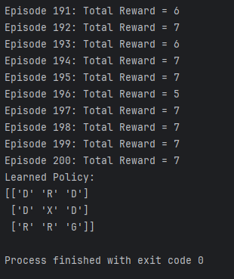

Practical 7
Aim: Utilizing transfer learning to improve model performance on limited datasets
Code
import tensorflow as tf
from tensorflow.keras.applications import MobileNet
from tensorflow.keras.models import Model
from tensorflow.keras.layers import Dense, Dropout, GlobalAveragePooling2D
from tensorflow.keras.optimizers import Adam
# Parameters
IMG_SIZE = 128 # Smaller image size for faster computation
BATCH_SIZE = 16 # Reduced batch size to save memory
EPOCHS = 2 # Fewer epochs for quicker training
LEARNING_RATE = 0.001
# Load and Preprocess MNIST Dataset
(x_train, y_train), (x_test, y_test) = tf.keras.datasets.mnist.load_data()
# Use only a subset of the data (e.g., 10,000 samples for training)
x_train, y_train = x_train[:10000], y_train[:10000]
x_test, y_test = x_test[:2000], y_test[:2000]
# Preprocessing function
def preprocess(image, label):
image = tf.image.resize(tf.expand_dims(image, axis=-1), (IMG_SIZE, IMG_SIZE)) / 255.0
image = tf.image.grayscale_to_rgb(image) # Convert grayscale to RGB
label = tf.one_hot(label, depth=10) # One-hot encode labels
return image, label
# Create TensorFlow datasets
train_dataset = (
tf.data.Dataset.from_tensor_slices((x_train, y_train))
.map(preprocess)
.batch(BATCH_SIZE)
.prefetch(tf.data.AUTOTUNE)
)
test_dataset = (
tf.data.Dataset.from_tensor_slices((x_test, y_test))
.map(preprocess)
.batch(BATCH_SIZE)
.prefetch(tf.data.AUTOTUNE)
)
# Load the smaller pre-trained MobileNet model
base_model = MobileNet(weights="imagenet", include_top=False, input_shape=(IMG_SIZE, IMG_SIZE, 3))
# Freeze the base model
base_model.trainable = False
# Add custom layers on top
x = base_model.output
x = GlobalAveragePooling2D()(x) # Reduce dimensions
x = Dropout(0.3)(x) # Dropout for regularization
predictions = Dense(10, activation="softmax")(x) # Output layer for 10 classes
# Create the full model
model = Model(inputs=base_model.input, outputs=predictions)
# Compile the model
model.compile(optimizer=Adam(learning_rate=LEARNING_RATE),
loss="categorical_crossentropy",
metrics=["accuracy"])
# Train the model
history = model.fit(
train_dataset,
validation_data=test_dataset,
epochs=EPOCHS
)
# Evaluate the model on the test dataset
evaluation = model.evaluate(test_dataset, verbose=1)
# Print the evaluation metrics
print(f"Test Loss: {evaluation[0]:.4f}")
print(f"Test Accuracy: {evaluation[1]:.4f}")
output
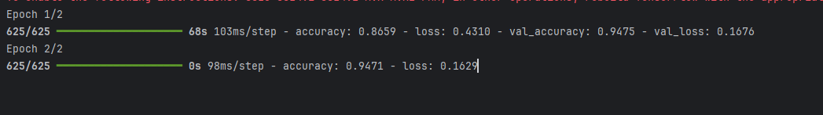

Practical 8
Aim: Building a deep learning model for time series forecasting or anomaly detection
Code
import numpy as np
import pandas as pd
import pandas as pd
import matplotlib.pyplot as plt
from sklearn.preprocessing import MinMaxScaler
from tensorflow.keras.models import Sequential
from tensorflow.keras.layers import LSTM, Dense
# 1. Prepare and normalize data
data = pd.DataFrame(np.sin(np.linspace(0, 100, 1000)), columns=['value'])
scaler = MinMaxScaler(feature_range=(0, 1))
scaled_data = scaler.fit_transform(data)
# 2. Create dataset for LSTM
X, y = [], []
for i in range(len(scaled_data) - 10):
X.append(scaled_data[i:i + 10, 0])
y.append(scaled_data[i + 10, 0])
X, y = np.array(X), np.array(y)
X = X.reshape(X.shape[0], X.shape[1], 1)
# 3. Split data into train and test
train_size = int(len(X) * 0.8)
X_train, X_test, y_train, y_test = X[:train_size], X[train_size:], y[:train_size], y[train_size:]
# 4. Build and train model
model = Sequential([LSTM(50, input_shape=(X_train.shape[1], 1)), Dense(1)])
model.compile(optimizer='adam', loss='mse')
model.fit(X_train, y_train, epochs=10, batch_size=32, verbose=0)
# 5. Predict and plot
predictions = scaler.inverse_transform(model.predict(X_test))
y_test = scaler.inverse_transform(y_test.reshape(-1, 1))
plt.plot(y_test, label='True')
plt.plot(predictions, label='Predicted')
plt.legend()
plt.show()
output
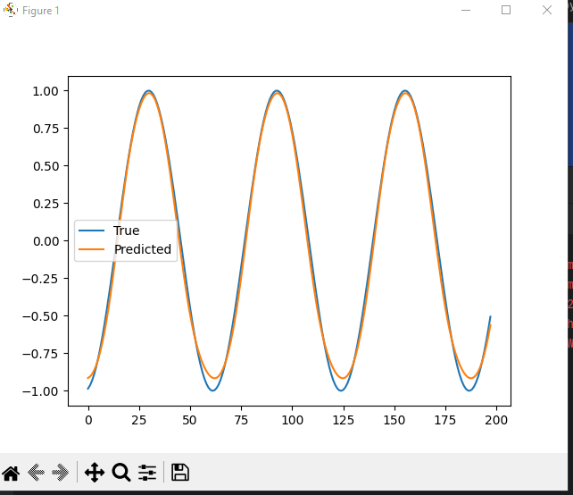

Practical 9
Aim: Implementing a machine learning pipeline for automated feature engineering and model selection.
Code
import pickle
import numpy as np
import pandas as pd
from sklearn.model_selection import train_test_split, cross_val_score, GridSearchCV
from sklearn.compose import ColumnTransformer
from sklearn.impute import SimpleImputer
from sklearn.preprocessing import OneHotEncoder, MinMaxScaler
from sklearn.pipeline import Pipeline
from sklearn.feature_selection import SelectKBest, chi2
from sklearn.tree import DecisionTreeClassifier
from sklearn.metrics import accuracy_score
from sklearn import set_config
# Load data
df = pd.read_csv(r'E:\Advanced AI\Titanic.csv')
df.drop(columns=['PassengerId', 'Name', 'Ticket', 'Cabin'], inplace=True)
# Split
X_train, X_test, y_train, y_test = train_test_split(
df.drop(columns=['Survived']), df['Survived'],
test_size=0.2, random_state=42
)
# Identify numeric and categorical columns
num_features = ['Age', 'SibSp', 'Parch', 'Fare']
cat_features = ['Sex', 'Embarked']
# Preprocessor
preprocessor = ColumnTransformer([
('num', Pipeline([
('imputer', SimpleImputer(strategy='mean')),
('scaler', MinMaxScaler())
]), num_features),
('cat', Pipeline([
('imputer', SimpleImputer(strategy='most_frequent')),
('ohe', OneHotEncoder(handle_unknown='ignore', sparse_output=False))
]), cat_features)
])
# Build full pipeline
pipe = Pipeline([
('preprocessor', preprocessor),
('feature_selection', SelectKBest(score_func=chi2, k=8)),
('classifier', DecisionTreeClassifier())
])
# Train
pipe.fit(X_train, y_train)
# Evaluate
y_pred = pipe.predict(X_test)
print("Accuracy:", accuracy_score(y_test, y_pred))
# Cross-validation
cv_score = cross_val_score(pipe, X_train, y_train, cv=5, scoring='accuracy').mean()
print("CV Mean Accuracy:", cv_score)
# Grid Search
params = {'classifier__max_depth': [1, 2, 3, 4, 5, None]}
grid = GridSearchCV(pipe, params, cv=5, scoring='accuracy')
grid.fit(X_train, y_train)
print("Best CV Score:", grid.best_score_)
print("Best Params:", grid.best_params_)
# Save model
pickle.dump(grid.best_estimator_, open(r'E:\Advanced AI\pipe.pkl', 'wb'))
# Optional: visualize pipeline
set_config(display='diagram')
pipe
output
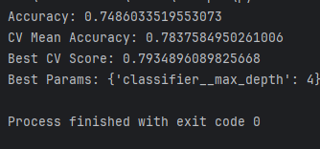

Predict.py
Code
import pickle
import numpy as np
import pandas as pd
pipe = pickle.load(open('E:/Advanced AI/pipe.pkl','rb'))
# Assume user input
test_input2 = np.array([2, 'male', 31.0, 0, 0, 10.5, 'S'],dtype=object).reshape(1,7)
# Adding a new row to the dataframe
# test_input2 = np.vstack([
# test_input2,
# np.array([12, 'female', 47.0, 0, 0, 54.3, 'C'], dtype=object).reshape(1, 7),
# np.array([3, 'male', 23.0, 0, 0, 12.3, 'S'], dtype=object).reshape(1, 7)
# ])
columns = ['Pclass', 'Sex', 'Age', 'SibSp', 'Parch', 'Fare', 'Embarked']
test_input2_df = pd.DataFrame(test_input2, columns=columns)
# Assume user input
print(pipe.predict(test_input2_df))
output
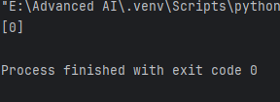

Practical 10
Aim: Using advanced optimization techniques like evolutionary algorithms or Bayesian optimization for hyperparameter tuning.
Code
from sklearn.datasets import load_iris
from sklearn.ensemble import RandomForestClassifier
from sklearn.model_selection import cross_val_score
from skopt import BayesSearchCV
from skopt.space import Real, Integer
# Load dataset
data = load_iris()
X, y = data.data, data.target
# Define the model
model = RandomForestClassifier(random_state=42)
# Define the search space for hyperparameters
param_space = {
'n_estimators': Integer(10, 200),
# Number of trees
'max_depth': Integer(1, 20),
# Maximum depth of a tree
'min_samples_split': Real(0.01, 0.3),
# Minimum fraction of samples required to split
'min_samples_leaf': Integer(1, 10),
# Minimum samples at a leaf node
'max_features': Real(0.1, 1.0),
# Fraction of features to consider for split
}
# Bayesian Optimization with Cross-Validation
opt = BayesSearchCV(
estimator=model,
search_spaces=param_space,
n_iter=50, # Number of parameter settings to try
cv=5, # Number of cross-validation folds
n_jobs=-1, # Use all processors
random_state=42
)
opt.fit(X, y)
# Results
print("Best Parameters:", opt.best_params_)
print("Best Cross-Validation Score:", opt.best_score_)
output

Practical 11

Aim - Use Python libraries such as GPT-2 or textgenrnn to train generative models on a corpus of text data and generate new text based on the patterns it has learned .

Code
from transformers import GPT2Tokenizer, GPT2LMHeadModel, TextDataset, DataCollatorForLanguageModeling, Trainer, TrainingArguments
import torch
# Step 1: Correct file path (use raw string to avoid \ errors)
file_path = r"F:\SEM 3 Notes Material\Advanced AI\.venv\data.txt"
# Step 2: Check if the file has content
with open(file_path, "r", encoding="utf-8") as f:
text = f.read().strip()
if len(text) == 0:
raise ValueError(" Your text file is empty! Please add some sentences before training.")
else:
print(f" Loaded text file successfully with {len(text)} characters.\n")
# Step 3: Load pretrained GPT-2 model and tokenizer
print(" Loading GPT-2 model and tokenizer...")
tokenizer = GPT2Tokenizer.from_pretrained("gpt2")
model = GPT2LMHeadModel.from_pretrained("gpt2")
# Step 4: Prepare dataset
print(" Preparing dataset for training...")
dataset = TextDataset(
tokenizer=tokenizer,
file_path=file_path,
block_size=32
)
data_collator = DataCollatorForLanguageModeling(
tokenizer=tokenizer,
mlm=False
)
# Step 5: Define training arguments
training_args = TrainingArguments(
output_dir="./gpt2-finetuned",
overwrite_output_dir=True,
num_train_epochs=1, # keep 1 for demo
per_device_train_batch_size=1,
save_steps=500,
save_total_limit=1,
logging_dir="./logs"
)
# Step 6: Create Trainer and start training
print(" Starting training (this may take a few minutes)...")
trainer = Trainer(
model=model,
args=training_args,
data_collator=data_collator,
train_dataset=dataset
)
trainer.train()
print(" Training complete!\n")
# Step 7: Generate new text
print(" Generating new text from the trained model...\n")
prompt = "Artificial intelligence is"
inputs = tokenizer.encode(prompt, return_tensors="pt")
outputs = model.generate(
inputs,
max_length=100,
num_return_sequences=1,
no_repeat_ngram_size=2,
top_k=50,
top_p=0.95,
temperature=0.9,
do_sample=True
)
generated_text = tokenizer.decode(outputs[0], skip_special_tokens=True)
print("💬 Generated Text:\n")
print(generated_text)

Output
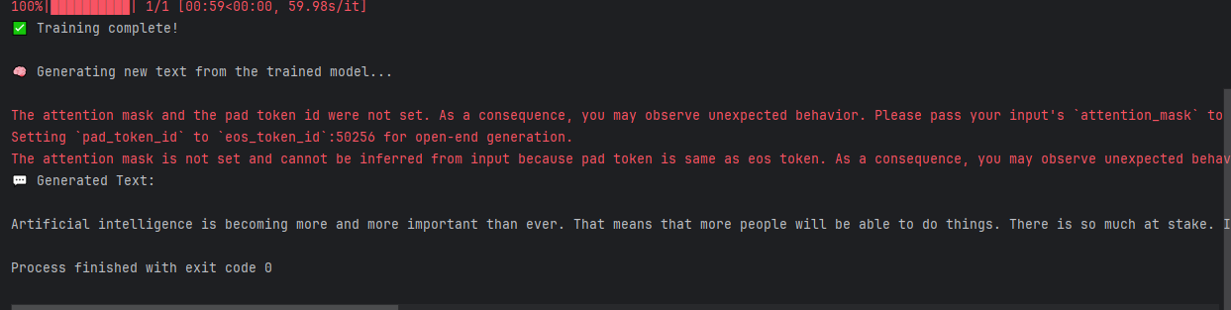

Practical 12
Aim - Experiment with neural networks like GANs (Generative Adversarial Networks) using Python libraries like TensorFlow or PY Torch to generate new images based on a dataset of images.

Code
import torch
import torch.nn as nn
import torch.optim as optim
# =========================
# 1. Generator Network
# =========================
class Generator(nn.Module):
def __init__(self, input_dim=100, output_dim=784): # 28x28 image flattened
super(Generator, self).__init__()
self.model = nn.Sequential(
nn.Linear(input_dim, 256),
nn.ReLU(True),
nn.Linear(256, 512),
nn.ReLU(True),
nn.Linear(512, output_dim),
nn.Tanh() # output values between -1 and 1
)
def forward(self, x):
return self.model(x)
# =========================
# 2. Discriminator Network
# =========================
class Discriminator(nn.Module):
def __init__(self, input_dim=784):
super(Discriminator, self).__init__()
self.model = nn.Sequential(
nn.Linear(input_dim, 512),
nn.LeakyReLU(0.2, inplace=True),
nn.Linear(512, 256),
nn.LeakyReLU(0.2, inplace=True),
nn.Linear(256, 1),
nn.Sigmoid()
)
def forward(self, x):
return self.model(x)
# =========================
# 3. Initialize Models
# =========================
device = torch.device("cuda" if torch.cuda.is_available() else "cpu")
generator = Generator().to(device)
discriminator = Discriminator().to(device)
# Confirm that parameters exist
print(f"Generator Parameters: {sum(p.numel() for p in generator.parameters())}")
print(f"Discriminator Parameters: {sum(p.numel() for p in discriminator.parameters())}")
# =========================
# 4. Optimizers
# =========================
lr = 0.0002
optimizer_G = optim.Adam(generator.parameters(), lr=lr)
optimizer_D = optim.Adam(discriminator.parameters(), lr=lr)
# =========================
# 5. Loss Function
# =========================
criterion = nn.BCELoss()
# =========================
# 6. Dummy Training Loop (for testing)
# =========================
epochs = 5
batch_size = 16
latent_dim = 100
for epoch in range(epochs):
# ----- Train Discriminator -----
real_data = torch.randn(batch_size, 784).to(device)
real_labels = torch.ones(batch_size, 1).to(device)
fake_labels = torch.zeros(batch_size, 1).to(device)
optimizer_D.zero_grad()
outputs = discriminator(real_data)
loss_real = criterion(outputs, real_labels)
z = torch.randn(batch_size, latent_dim).to(device)
fake_data = generator(z)
outputs = discriminator(fake_data.detach())
loss_fake = criterion(outputs, fake_labels)
loss_D = loss_real + loss_fake
loss_D.backward()
optimizer_D.step()
# ----- Train Generator -----
optimizer_G.zero_grad()
z = torch.randn(batch_size, latent_dim).to(device)
fake_data = generator(z)
outputs = discriminator(fake_data)
loss_G = criterion(outputs, real_labels) # want discriminator to think fake is real
loss_G.backward()
optimizer_G.step()
print(f"Epoch [{epoch+1}/{epochs}] | Loss D: {loss_D.item():.4f}, Loss G: {loss_G.item():.4f}")
print("\n Training complete! Generator and Discriminator working fine.")

Output
